FORT BEND COUNTY JUVENILE PLAN AND LOCAL RULES FOR THE APPOINTMENT OF COUNSEL
TO INDIGENT DEFENDANTS
IN THE DISTRICT AND COUNTY COURTS OF FORT BEND
COUNTY, TEXAS, PURSUANT TO ART. 26.05, ET SEQ., TEXAS RULES OF CRIMINAL PROCEDURE
(Amended September 30, 2025)
Preamble
Pursuant to Senate Bill 7, 77Th Legislative 2001, the Judges of the Juvenile Board of Fort Bend County, Texas hereby adopts a plan for the appointment of counsel for indigent cases in juvenile matters, with the following goals: The plan must state financial standards and procedures to be utilized by all the courts in the county for determining who is indigent. The plan must ensure that appointments are allocated among qualified attorneys in a manner that ' is fair, neutral, nondiscriminatory and impartial. The plan must: ensure that attorneys who are appointed meet a countywide set of written, objective qualification standards approved by the judges. There should be a separate set of qualification standards for misdemeanor and felony courts. There may be additional qualification tiers tailored to the seriousness of the case. The plan should set fair and reasonable fees for the payment of attorneys, as well, as related expenses of the attorney.
I.
Prompt Detention Hearings
A. Child taken into custody must either be brought to a juvenile processing office without unnecessary delay where they may not be detained for longer than six hours pursuant to 552.025, Family Code, or another disposition authorized by 552.02, Family Code, including referral to the office designated by the juvenile board as intake for the juvenile court. The intake officer shall process the child according to the requirement of 553.01, Family Code, and shall also inform the child and the child's parents of the right to appointed counsel if they are indigent and provide a form for the purpose of determining eligibility for appointment of counsel. If the child is not released by intake, then a Detention Hearing shall be held not later than the second working day after the child is taken into custody unless the child is detained on a Friday, Saturday or listed holiday in which case the detention hearing shall be held on the first working day after the child is taken into custody.
B. Prior to the detention hearing the court shall inform the parties of the child's right to counsel and to appointed counsel if they are indigent, and of the child's right to remain silent as to the alleged conduct.
C. The detention hearing may be conducted without the presence of the child's parent(s) or other responsible adult(s), however, in these cases the court must immediately appoint counsel or a guardian ad litem to represent the child.
D. The court shall provide the attorney for the child access to all written matter to be considered by the Court in making the detention decision.
II.
Indigence Determination Standards
Financial Report on Parents Ability to Hire an Attorney to represent a Juvenile Respondent and the Juvenile is not Represented by Counsel, form is attached in the forms section.
A. Definitions, as used in this rule:
i. "Indigent" means a person who is not financially able to employ counsel.
ii. "Net household income" in the case of a child is the income of the child's parents or other person determined responsible for the support of the child. Such income shall include: take home wages and salary (gross income earned minus those deductions required by law or as a condition of employment); net self-employment income (gross income minus business expenses, and those deductions required by law or as a condition of operating the business); regular payments from a governmental income maintenance program, alimony, child support, public or private pensions, or annuities; and income from dividends, interest, rents, royalties, or periodic receipts from estates or trusts. Seasonal or temporary income shall be considered on an annualized basis, averaged together with periods in which the person determined responsible for the support of the child has no income or lesser income.
iii. "Household" means all individuals who are actually dependent on the child's parent(s) or person(s) deemed responsible for the support of the child, for financial support.
iv. "The cost of obtaining competent private legal representation" includes the reasonable cost of support services such as investigators and expert witnesses as necessary and appropriate given the nature of the case.
B. Eligibility for Appointment
i. A child is presumed indigent if any of the following conditions or factors are present:
- At the time of requesting appointed counsel, a child is presumed indigent if the child's parent(s) or other person(s) determined responsible for the support of the child is eligible to receive food stamps, Medicaid, Temporary Assistance for Needy Families, Supplemental Security Income, or public housing.
- The net household income of the child's parent(s) or other person(s) determined responsible for the support of the child does not exceed 130% of the Poverty Guidelines as revised annually by the United States Department of Health and Human Services and published in the Federal Register; with guidelines from the current year being the base year.
- The child's parent(s) or other person(s) determined responsible for the support of the child is currently serving a sentence in a correctional institution, Immigration center, or is currently residing in a public mental health facility, or is subject to a proceeding in which admission or commitment to such a mental health facility is sought; or
ii. The child who does not meet any of the standards above shall nevertheless be considered indigent if the child's parent(s) or other person(s) responsible for the child is unable to retain private counsel without substantial hardship. In considering if obtaining private counsel will create a substantial hardship, the appointing authority shall take into account:
- The nature of the charge(s);
- Anticipated complexity of the defense;
- The estimated cost of obtaining competent private legal representation for the matter(s) charged;
- The amount needed for the support of the child, the child's parent(s)/person(s) responsible, and other dependents of the child' s parent(s)/person(s) responsible;
- Child's parent(s') income or the income of other person(s) determined responsible for the support of the child;
- Source of income;
- Assets and property owned by the child, child's parent(s), or other person(s) determined responsible for support of the child;
- Outstanding obligations;
- Necessary expenses; and
- The number and ages of any siblings of the child.
iii. Factors NOT to be considered in determining indigence:
1 . The resources available to friends or relatives of the child, other than the child's parent(s) or other person(s) deemed responsible for the child, may not be considered in determining whether the child is indigent.
2. Only the child's parent(s) or other person(s) responsible for the child and the child's financial circumstances as measured by the financial standards stated in this rule shall be used as the basis for determining indigence.
C. Indigence Proceedings:
- The appointing authority can require the child and the child's parent(s) or other person(s) responsible for the child to respond to questions about the child's household financial status, produce documentation supporting financial information provided, and/or order a court official to verify financial information provided.
- Information gathered for determining indigence, both in the affidavit of indigence and through oral examination, may not be for any purpose other than:
l. Determining if child is (or is not) indigent; or
2. Impeaching direct testimony of the child or the child's parent(s)/person(s) responsible regarding the child's indigence.
- A request by the appointing authority for additional information, documentation, and/or verification cannot delay appointment of counsel beyond the timelines specified in Parts I and IV of these rules.
- A child determined to be indigent is presumed to remain indigent for the remainder of the case a material change in the child's financial circumstances occurs.
l. A child's status as indigent or not indigent may be reviewed in a formal hearing at any stage of a court. The child's indigent status will be presumed not to have changed. The presumption can be rebutted in the review proceedings based on the following:
a. Evidence of a material change in the child's parent(s)/person(s) responsible and the child's financial circumstances; or
b. Additional information regarding the child's parent(s)/person(s) responsible and the child's financial circumstances that shows that they do not meet any of the standards for indigence contained in these rules.
2. If a child previously determined to be indigent is subsequently determined not to be indigent, the attorney shall be compensated by the county according to the fee schedule for hours reasonably expended on the case.

III.
Minimum Attorney Qualifications
Offensive Level | Lawyer Qualifications | Suggested  Hourly Rate
CINS  And  Indeterminate Where TJJD not possible | Practice for 1 year, or  I misdemeanor or felony jury trial to verdict (first chair); or 1 civil jury trial to verdict; and  Experience in gathering and using disposition/mitigation evidence; and  1 Evidentiary Hearing (Misdemeanor or Felony);  Complete at least 6 hours of continuing legal education pertaining to juvenile law during each 12-month reporting period or be currently certified in juvenile law by the Texas Board of Legal Specialization. (1 TAC 5174.1-174.4); and  Attend Minimum 6 hours State Bar Juvenile Seminar where available | 100-175
Indeterminate  TJJD  Possible | Practice for 2 years; or  2 Misdemeanor Jury Trials (1 as first chair); or  I Felony Jury Trial (first chair); or  1 Misdemeanor Jury Trial and 1 civil jury trial to verdict; and Experience in gathering and using disposition/mitigation evidence; and  1 Evidentiary Hearing (Misdemeanor or Felony)  Experience in Motions Practice; and  See CLE from above; and  Attend Minimum 6 hours State Bar Juvenile Seminar where available | 100-175
Determinate | Practice 3 years; and  4 Felony Jury Trials to verdict (3 as first chair); and  Experience in using and cross-examining expert witnesses; and Experience in gathering and using disposition/mitigation evidence; and  Experience in using investigators; and  Experience in Motions Practice; and  See CLE from above; and  Attend Minimum 6 hours State Bar Juvenile Seminar where available | 100-350
Certification | Practice 3 years; and  4 Felony Jury Trials to verdict (3 as first chair); and  1 Competency Hearing or experience dealing with psychological or psychiatric testimony  Experience in using and cross-examining expert witnesses; and Experience in gathering and using disposition/mitigation evidence; and  Experience in using investigators; and  Experience in Motions Practice; and  See CLE from above; and  Attend Minimum 6 hours State Bar Juvenile Seminar where available | 100-350

IV.
Appointment in Juvenile Cases
An attorney who meets the requirements of this rule may be appointed to represent an indigent juvenile detained for or accused of engaging in delinquent conduct or conduct indicating a need for supervision, if the attorney is otherwise eligible to be appointed under the Appointment of Counsel Plan. Attorneys must be approved by a majority of the Juvenile Board or presiding juvenile judges to be placed on or removed from the appointment list. [Sec. 51.102 (a), FC & Art. 26.04, CCP]
An attorney may be appointed under this rule only if the attorney:
- Completes a minimum of six hours of continuing legal education pertaining to juvenile law during each 12-month reporting period. The first reporting period will begin on December 31, 2017, and then on the first day of each reporting period thereafter.
Continuing legal education may include activities accredited under Section 4, Article XII, State Bar Rules, self-study, teaching at an accredited continuing legal education activity, attendance at a law school class or legal research-based writing; or
- Is currently certified in juvenile law by the Texas Board of Legal Specialization.
Reporting Period.
(1) Continuing legal education activity completed within a one-year period immediately preceding an attorneys initial reporting period may be used to meet the educational requirements for the initial year.
(b) Continuing legal education activity completed during any reporting period in excess of the minimum six-hour requirement for such period may be applied to the following period's requirement. The carryover provision applies to one year only.
(c) To be included on the appointment list, each attorney must annually submit an affidavit, attached hereto as "Addendum D", to the Fort Bend County Court Services Coordinator, or designee detailing the juvenile continuing legal education activities completed in the prior year. Alternatively, an attorney may annually submit documentation showing the attorney is currently certified as a specialist in juvenile law, using said addendum.
Emergency Appointment.
If no attorney who meets these continuing legal education or board certification requirements is available by the time an attorney must be appointed in a case, another attorney may be appointed. The person making an appointment shall give priority to an attorney with experience in juvenile law
An attorney shall submit by October 15th each year a statement that describes the percentage of the attorney's practice time that was dedicated to work based on appointments accepted in this county for adult criminal cases and juvenile delinquency cases for the prior 12 months that begins on October 1 and ends on September 30. The report must be submitted through the online form to the Texas Indigent Defense Commission.
V.
Prompt Appointment of Counsel
- Indigence
A uniform application on the financial status of the child's parents shall be created and used by the judge presiding at the proceeding to determine if a child's parents are financially able to retain adequate counsel.
- Detained
If the child is detained and found indigent, the court shall immediately appoint an attorney for the child, but in no case more than three working days after the child is detained.
- Child not in custody
If the child is released at the initial detention hearing, or was released by intake, or referred to the juvenile court without being in custody, then when and if a petition is filed, a child declared indigent shall be appointed an attorney not later than 5 working days after the petition is served on the child.
- Modification of Probation
If a child declared indigent is already on probation and a Motion to Modify is filed that seeks commitment to the Texas Juvenile Justice Department, a secured facility boot camp, residential placement, or any placement outside the home requires the prompt appointment of counsel.
- Appointment of Attorney at Initial Detention Hearing
Unless the court finds that the appointment of counsel is not feasible due to exigent circumstances, the court shall appoint counsel within a reasonable time before the first detention hearing is held to represent the child at that hearing.
Fort Bend County Supplemental Plan for appointment of Counsel:
  - majority of the Juvenile Board having approved it, this Supplemental Plan is added to and is now a part of the Plan for Appointment of Counsel as follows:
Reasonable and Necessary Expenses
    - The appointment of and reimbursement for reasonable and necessary investigation, mental health, and other expert witness expenses with prior Court approval shall be as provided by Art. 26.05(d) and Art. 26.052(f) and (g) Texas Code of Criminal Procedure and only upon written motion and prior approval of the trial judge. A complete and true statement of expenses incurred by the person appointed shall be submitted to the trial judge with the request for reimbursement by appointed counsel, including a certification by said counsel that the expenses were duly rendered by the said claimant.
    - The appointment of and reimbursement for reasonable and necessary investigation, mental health, and other expert witness expenses without prior written approval, as provided by Art. 26.05(d) Texas Code of Criminal Procedure, shall be paid pursuant to said statute, and Art. 26.052(h) Texas Code of Criminal Procedure. A complete and true statement of expenses incurred by the person appointed shall be submitted to the trial judge with the request for reimbursement by appointed counsel, including a certification by said counsel that the expenses were duly rendered by the said claimant.
    - A request for advance payment of investigative and expert expenses may be made by appointed counsel Ex Parte. Appointed counsel may file with the trial judge a pretrial, ex parte, and confidential request for advance payment of investigative and expert expenses. The request for such expenses must state, as applicable:
      - The type of investigation to be conducted or the type of expert to be retained;
      - The specific facts that suggest the investigation will result in admissible evidence or that the services of an expert are reasonably necessary to assist in the preparation of a potential defense; and
      - An itemized list of anticipated expenses for each investigation or each expert.
The judge shall grant such Ex Parte request for advance payment of expenses, in whole or in part, if the request is reasonable. If the judge denies in whole or in part the request for expenses, the judge shall:
      - State the reasons for the denial in writing:
      - Attach the denial to the confidential request; and
      - Submit the request and denial as a sealed exhibit to the record.
    - Unreasonable or unnecessary expenses will not be approved.
VI.
Attorney Selection Process
The Court shall appoint an attorney from the public appointment lists adopted by the Juvenile Board using a system of rotation based on the qualifications of the attorney and level of the offense. The court shall appoint attorneys from among the next five names on the appointment list in the order in which the attorney's name appears on the list, unless the court makes a finding of good cause on the record for appointing an attorney out of order. An attorney who is not appointed in the order in which the attorney's name appears on the list shall remain next in order on the list. If an indigent is otherwise qualified as bi-lingual or communicates in sign language or braille, the court may appoint the next qualified attorney without regard to their position on the rotation list.
Vll.
Fee and Expense Payment Process
- Court appointed counsel shall be compensated for all reasonable and appropriate services rendered in representing the accused. Compensation shall be reasonable for time and effort expended and will be in accordance with a fee schedule adopted and approved by the Juvenile Board.
- Payment Process - No payment of attorney's fees will be made other than in accordance with the rules set forth below.
  - An appointed attorney shall fill out and submit a fee voucher to the court for services rendered.
  - The trial judge presiding over the proceedings shall review the request for compensation and either approve or disapprove of the amount requested.
  - If a judge disapproves a request for compensation, the judge shall make written findings, stating the amount of payment that the judge approves and each reason for approving an amount different from the requested amount.
  - An attorney whose request for payment is disapproved or is not otherwise acted on by the 60th day after the date the request for payment is submitted may appeal the disapproval or failure to act by filing a motion with the presiding judge of this administrative judicial region.
C. Payment of Expenses:
i. Court appointed counsel will be reimbursed for reasonable and necessary expenses incurred, including expenses for investigation and for mental health and other experts. Expenses incurred with and without prior approval shall be paid according to the procedures set forth below. Whenever possible prior court approval should be obtained before expenses are incurred.
ii. Procedure with Prior Court Approval:
    - Appointed Counsel may file with the trial court a pretrial ex parte confidential request for advance payment of investigative and expert expenses. The request for expenses must state the below, as applicable:
      - The type of investigation to be conducted or the type of expert to be retained;
      - Specific facts that suggest the investigation will result in admissible evidence or that the services of an expert are reasonably necessary to assist in the preparation of a potential defense; and
      - An itemized list of anticipated expenses for each investigation and/or each
expert.
    - The court shall grant the request for advance payment of expenses in whole or in part if the request is reasonable. If the court denies in whole or in part the request for expenses, the court shall:
      - State the reasons for the denial in writing;
      - Attach the denial to the confidential request; and
      - Submit the request and denial as a sealed exhibit to the record.
iii. Procedure without Prior Court Approval:
l. Appointed counsel may incur investigative or expert expenses without prior approval of the court. On presentation of a claim for reimbursement, the court shall order reimbursement of counsel for the expenses, if the expenses are reasonably necessary and reasonably incurred. Unreasonable or unnecessary expenses will not be approved.
2. Investigation Fees/Out of Pocket Expenses:
a. Attorneys representing indigent children should be reimbursed for out of pocket expenses and provided with appropriate funds to retain investigators.

Attached Forms
Addendum A:  Addendum B:  Addendum C:  Addendum D: | Financial Report on Parents' Ability to Hire an Attorney to Represent a  Juvenile and the Juvenile is not represented by Counsel  Application for Juvenile Appointments in Fort Bend County  Attorney's Fee/Expense Claim and Certification  Annual Affidavit of Confirming CLE and requesting to be Continued Annually

The above and foregoing "FOURTH" AMENDED FORT BEND COUNTY JUVENILE PLAN AND LOCAL RULES FOR THE APPOINTMENT OF COUNSEL TO INDIGENT DEFENDANTS IN THE DISTRICT AND COUNTY COURTS OF FORT BEND COUNTY, TEXAS, PURSUANT TO ART. 26.05, ET SEQ., TEXAS RULES OF CRIMINAL PROCEDURE" was considered at a regularly called Juvenile Board Meeting by those judges whose jurisdiction includes criminal (felony and misdemeanor) cases, as set out below.
APPROVED and ADOPTED this the 30th day of September, 2025.
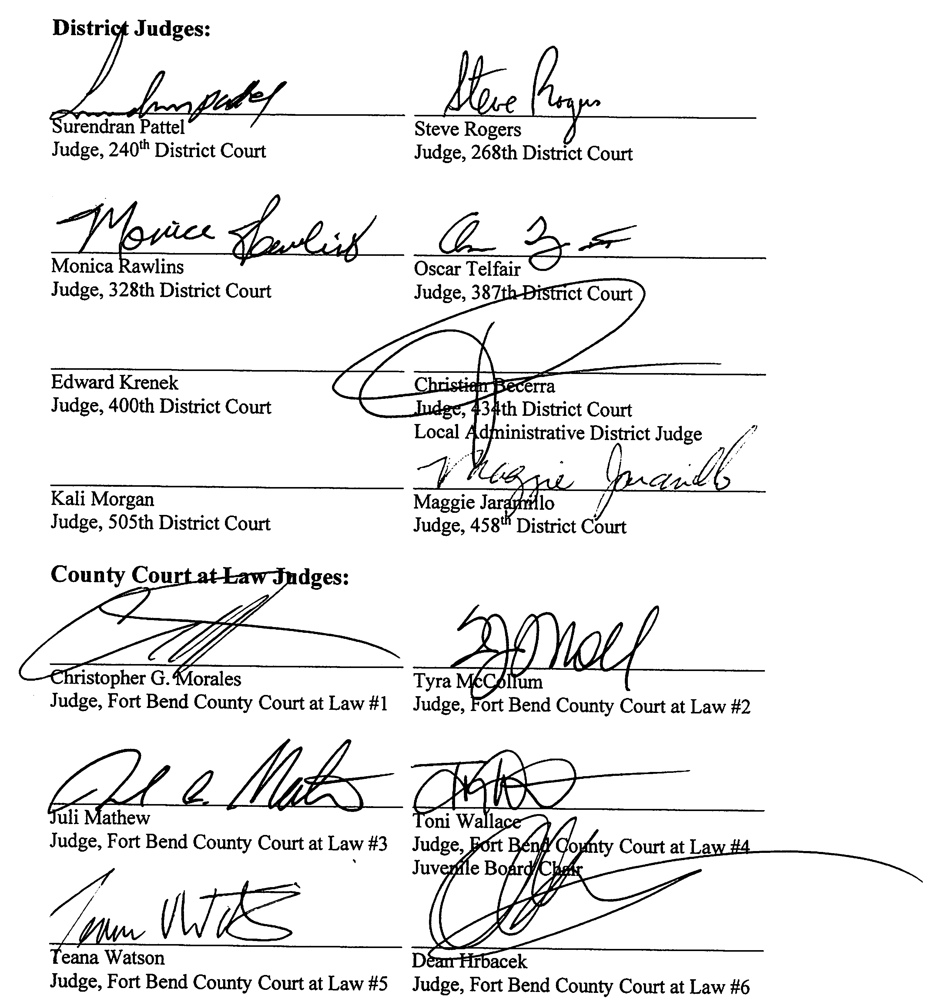

County Judge

K.P. George
Fort Bend County Judge

